# 1. Introduction

Goal of Project:

Learn as much as possible about basic python

TABLE OF CONTENTS

* 1. Introduction
* 2. Body
  + 2.1. Basic Information
    - 2.1.1. Building and Compiling
      * 2.1.1.1. Command Line Python Interpreter
      * 2.1.1.2. .py Files
      * 2.1.1.3. Advanced Interpreter
  + 2.2. Syntax
    - 2.2.1. White Space
  + 2.3. Variables
    - 2.3.1. Built in Scalar Types
    - 2.3.2. Data Structures
      * 2.3.2.1. Examples
  + 2.4. Math
  + Input and Output
    - Screen
    - Files
  + 2.5. Functions
  + 2.6. Imports

# 2. Body

|  |  |
| --- | --- |
| Need to show | How to show |
| Compiling and Debugging | Console |
|  | .Py File |
|  | Jupyter Labs |
| Basic programing Structures | Variables |
|  | Operations |
|  | Whitespace |
|  | imports |
|  | Scope |
| Data structures | Arrays |
| Functions |  |
| Input |  |
| Output |  |

## 2.1. Basic Information

This solution simply presents the basic information of python AND will not have any asociated code.

### 2.1.1. Building and Compiling

Runing python is different to other languages because you can run python through multiple means.

#### 2.1.1.1. Command Line Python Interpreter

Python can be run in the command line. To get started type **py** into the command line.

You will then see the following text in your command line, informing you have just launched the command line python interpreter.

Python 3.8.8 (default, Apr 13 2021, 15:08:03) [MSC v.1916 64 bit (AMD64)] :: Anaconda, Inc. on win32

Warning: This Python interpreter is in a conda environment, but the environment has not been activated. Libraries may fail to load. To activate this environment please see https://conda.io/activation

Type “help”, “copyright”, “credits” or “license” for more information.

If you did not see this text it is advised that you check your instalation of python.

Here you can type any line of code such as

>>>print("Hello World")  
Hello World

#### 2.1.1.2. .py Files

Another way to work with python is to write the code into a text file with the extension .py. Any .py file can be quickly read.

One example is the code below

x = 0  
x += 1  
x *= 5  
print("High", 5)

This will output

High 5

There are two ways to run these files,

1. Open the File in an IDE such as Juyyter Lab IDE or Visual Studio Code
   1. Right Click the file and select OPEN WITH
   2. Select the IDE of your choice
   3. These IDE’s will allow you to run the file. In VSCode you will need to install the proper extension to run python files.
2. Run the files via command line.
   1. Loacte the file in command line (you can use cd < folder name > if it is not in your root direcotry)
   2. Type python < file name >
   3. A python interpreter will launch showing your output

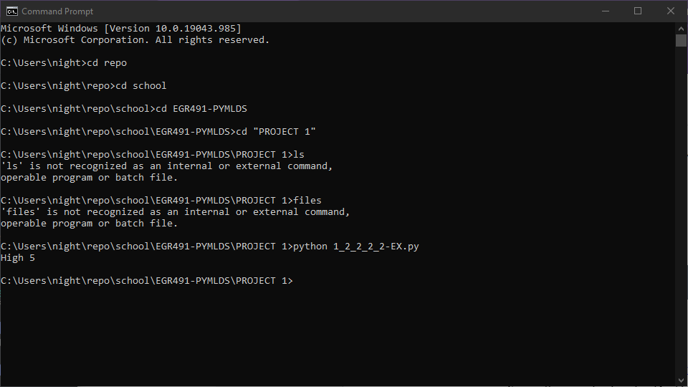

COMAND LINE OUTPUT

#### 2.1.1.3. Advanced Interpreter

There are other interpreters and IDE’s for python. The best of these come in the conda package which includes the Spyder IDE and Jupyter Labs interpreter.

The difference between an IDE and Interpreter when it comes to python is that the IDE is more tradional. You write your code then you run it. In an interpreter you can write and run your code line by line or in short segments. Below is an example image from the Juypter Labs extension for Visual Studio Code.

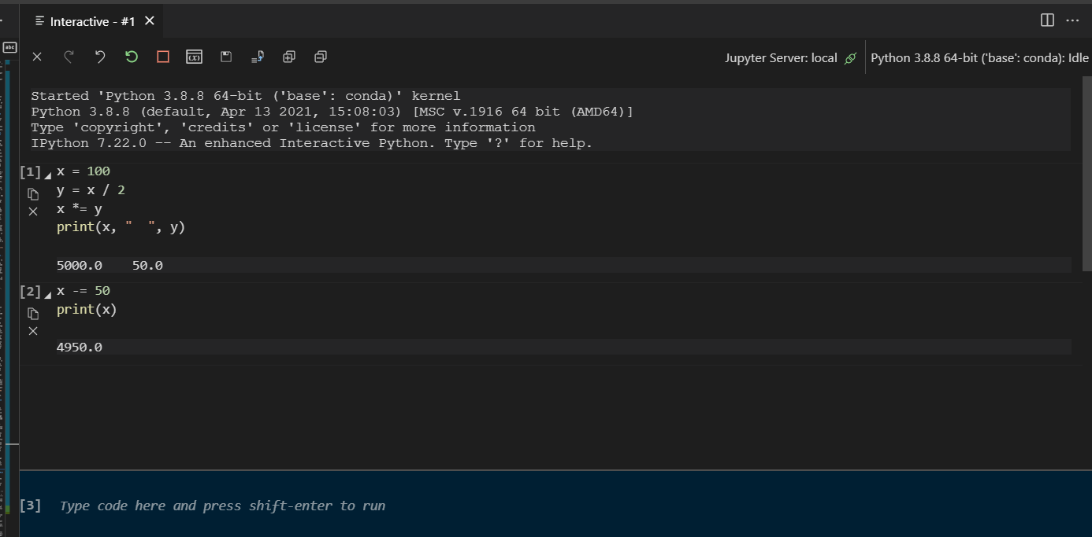

JUPYTER LAB EXAMPLE

## 2.2. Syntax

Python has a very lax syntax compared to many languages. The worst or best of these is that python does not require a semicolon at the end of each line. But there are a few differences between python and languages like Java.

### 2.2.1. White Space

In Java white space is generally ignored and is simplied used to increase readability. But python white space is used to distinguis blocks of code. For example the code below is invalid.

def sayHi():  
print("hi")

And the output of the file makes it clear that line 2 is borken.

File "c:/Users/night/repo/school/EGR491-PYMLDS/examples/2-2_exmpl.py", line 2  
print("HI")  
^

To fix this simply add a couple spaces before your

def sayHi():  
 print("Hi")

Another attribute of python is that every funtion and variable’s scope begins at its defintion in the file or interpreter.

## 2.3. Variables

Python is an object oriented programing lanuages and all variables avalible are objects. Unlike Java python variables are acutally pointers. Because of this it does not matter the type of your variable. Consider the code below,

x = 5 # x is an integer  
x = 'BONJOUR' # x is a string

Those familiar with languages like Java and Ada will know that this does not happen normally. This is because of variables in python being pointers.

### 2.3.1. Built in Scalar Types

Python includes common built in types such as

* int
* float
* bool
* str (String type)

Python also includes a few uncomon types

* complex: Complex Number such as 1 + 1j
* NoneType: This represents a Null value

### 2.3.2. Data Structures

Arrays are ubiqutus to programing and are neccesary for many applications. Thus many languages have many types of arrays and other related data structures. Pythons four built in data stuctures cover many of the needs of data science and mathmatics.

* **Lists** are common ordered lists and can be assed by using a command separated list with “,”’s between each item between squre brackets.
* **Tuples** are immuatable (unchanging) list. This is assigned list a normal list but with
* **Sets** This are unordered lists but sets can only have unique values. To assign a set put a comma separated list between curly brackets *{}*
* **Dicts** or dictionaries are sets with contain a key value mappings. to assign a dict to a variable each key value parir will be setparated by commands with a colon between the key and value like this “x = {‘key1’:1,‘key2’:2}”

Below is an example of how to use and access each of these arrays

#### 2.3.2.1. Examples

lst = [1,"two",3, [4,5]]  
  
print(lst) # Prints the whole list  
print(lst[0]) # Prints list item 1  
print(lst[-1]) # Prints the last Item of the list  
print(lst[2:]) # Prints Items from index to on  
print(lst[:3]) # Prints Items 0 to three  
print(lst[1:3]) # Prints Items 1, 2 and 3  
print(lst[-3:]) # Prints the last three items  
lst.append("THIS WORKS")  
print(lst)

OUTPUT

[1, 'two', 3, [4, 5]]  
1  
[4, 5]  
[3, [4, 5]]  
[1, 'two', 3]  
['two', 3]  
['two', 3, [4, 5]]  
[1, 'two', 3, [4, 5], 'THIS WORKS']

tup = (0,1,2)  
# you can do the same things as you do with lists  
print(tup)  
print(tup[1])  
# you cannot modify the tupple in any way  
tup[1] = 7 # This gives a TypeError because

OUTPUT

(0, 1, 2)  
1  
Traceback (most recent call last):  
 File "c:/Users/night/repo/school/EGR491-PYMLDS/PROJECT 1/Example3.py", line 6, in <module>  
 tup[1] = 7  
TypeError: 'tuple' object does not support item assignment

setObj = {0,1,2}  
#The Same as a tupple or a list  
print(setObj)  
# But you do have access to unique operations  
print(setObj.union({2,3,4,5})) # Union: outputs all items contained in the sets duplicates are ignored you can also use |  
print(setObj.intersection({1,7,9})) # Intersection: outputs the items shared in each set: you can also use &  
print(setObj.difference({0,2})) # Difference: outputs the items in setObj but not in the interal set you can also use -  
print(setObj.symmetric_difference({0,2,9})) #Symetric Difference outputs items that are in either list but not both you can also use ^

OUTPUT

{0, 1, 2}  
{0, 1, 2, 3, 4, 5}  
{1}  
{1}  
{9, 1}

dic = {1:"THIS",2:"THAT",3:"NOT"}  
pritn(dic[1]) # In this case you must access by a key not by the index  
#Adding a new key value pair  
dic["SWITCH"] = 99  
print(dic)  
print(dic["SWITCH"])

OUTPUT

THIS  
{1: 'THIS', 2: 'THAT', 3: 'NOT', 'SWITCH': 99}  
99

## 2.4. Math

In this solution we will show the basic mathmatical operations of python. This include the following:

|  |  |  |
| --- | --- | --- |
| Operation |  |  |
| + | Addition | Adds the two operators |
| - | Subtraction | Subtracts the first operator from the second |
| * | Multiplication | Multiplies the two operators |
| ** | Power | Raser the first operator to the second |
| / | Nomal Dvision | Divides the frist operator by the second |
| // | Integer Division | Divides the first operator by the second with no remander |

* CODE

x = 7  
print(x)  
y = x + 5 # y = 12  
print(y)  
y = x * 2 # y = 14  
print(y)  
y = x ** 2 # y = 49  
print(y)  
y = x / 2 # y = 3.5  
print(y)  
y = x // 2 # y = 3  
print(y)

* OUTPUT

7  
12  
14  
49  
3.5  
3

## Input and Output

### Screen

### Files

## 2.5. Functions

## 2.6. Imports

In Java you can get predesigned packages by doing, “import package_name.” In python there are not packages but **modules** which must first be installed. There are some good preinstalled such as numpy adds extended mathmatical abilities.

If you wish to use thrid party modules you follow the same syntax just ensure that they are installed. The most common way to instal python modules is using pip, below is an example of how to install the pygame modules which adds fun ways to make games.

pip install pygame

A warning to those who are just installing python for the first time. Make sure to install python to the PATH during the install process this will make using pip much easier.